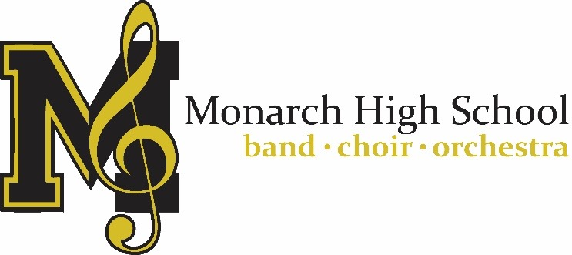

TAX RECEIPT

Please print and retain for your records

Monarch HS Band Boosters
Tax ID 81-0598147
329 Campus Drive
Louisville CO 80027

The purpose of the Band Boosters is to provide support for the Monarch High School Instrumental Music programs financially and to support music education in general at Monarch High School by:
- Coordinating, organizing and running fundraising efforts and donation campaigns
- Helping to provide for needs within the Monarch Music Department
- Supporting students in competitions and events
- Receiving funds, developing budgets, and managing expenses for each ensemble within the Instrumental Music program.

Items donated: ________________________________________________________
Estimated value: $ __________________

The IRS states it's the donor's responsibility to determine the value of the donation. Items donated to Monarch HS Band Boosters may be deductible for income tax purposes at their fair market value. The US Internal Revenue Service (IRS) requires donors to value their donated items rather than the agency receiving the donated item. The IRS generally defines "fair market value" as the price at which property would change hands between a willing buyer and a willing seller, neither having to buy or sell and both having reasonable knowledge of all relevant facts. The rules governing valuation, record keeping and reporting can be complex and we recommend obtaining IRS publications 526 and 561 and/or consulting a tax advisor if your situation so warrants. Please understand that we do not provide tax advice. No goods or services were provided by Monarch HS Band Boosters.

